Chamavita

P.O.Box292, Lushoto, Tanzania SPOT Tanzania, the Netherlands
Tel.: +255-0755-358-657 tel: +31 2539 1381, mail: kees@spottanzania.nl
Email:chamavita@yahoo.com Website: www.spottanzania.nl
Website: www. chamavita.nl

Interim Report of Baby Calabash Project

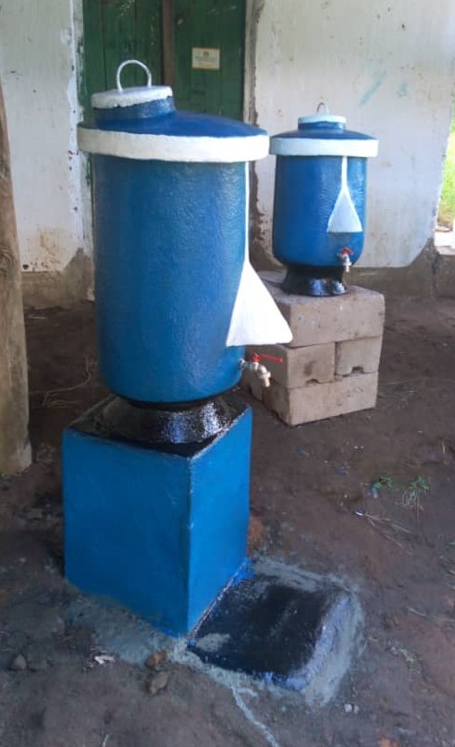
In front of Kinko village office, the production of Baby Calabash tanks, hand wash points, 20 liters of contents.

December 2020
Report written and edited by Fortunatos Kisoka and Kees Kempenaar
Baby Calabash constructed up to November 2020
Introduction:
The Baby Calabash is developed from 2015 onwards. The start idea was to have an easy water store with a tap in the kitchen area. When the Covid – 19 problem started end 2019 – start 2020 it became also an easy hand washing point for families, (also extended families), schools, mosques, churches, village offices and shops.
The contents of this tank is 20 liters, one can construct also bigger ones of 30, 40 liters, etc.
The construction principle is the same as the big one of 5,000 liters. The cost price (for a 20 liter size) is around €46.—per tank. It can be a small bit more or less depending on the prices of the construction material on the spot.
In contrast with the small plastic reservoirs the water in the baby calabash remains always cool.
Narrative and Financial
CHAMAVITA on 15th June,2020 received 460 EURO, to implement Baby Calabash Project in Lushoto for hand washing.
Up to November,2020. we have already constructed ten (10) Baby Calabash in different areas in Lushoto Tanga.
- Two baby Calabash, one in CHAMAVITA Office Lushoto and another one in Kinko Office. We constructed these two tanks in one area (Kinko), then we transported one baby calabash to Lushoto in CHAMAVITA Office.
- Cost for construction of those two baby calabash tanks is as follows::-

S/No. | ITEM | COSTS
1. | Labor | 78,000.00
2. | Materials | 117,000.00
3. | Transport | 10,000.00
 | TOTAL | 205,000.00
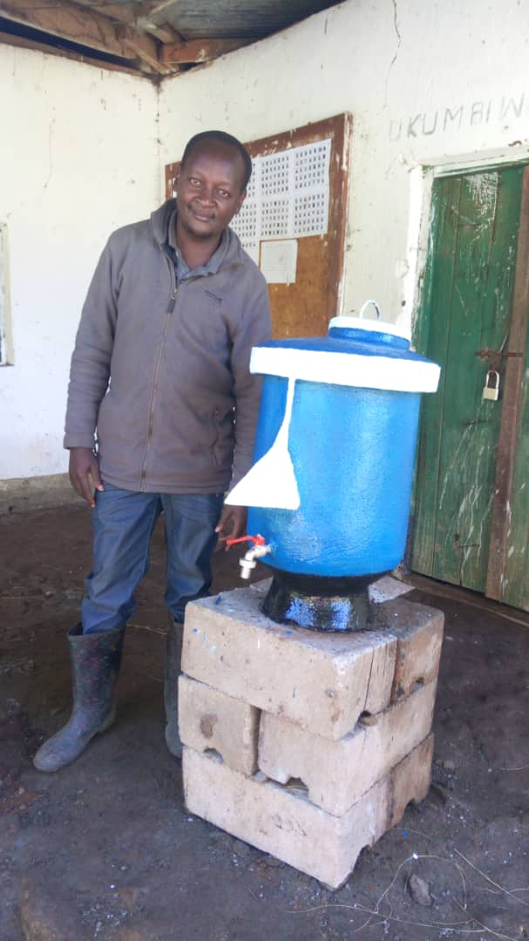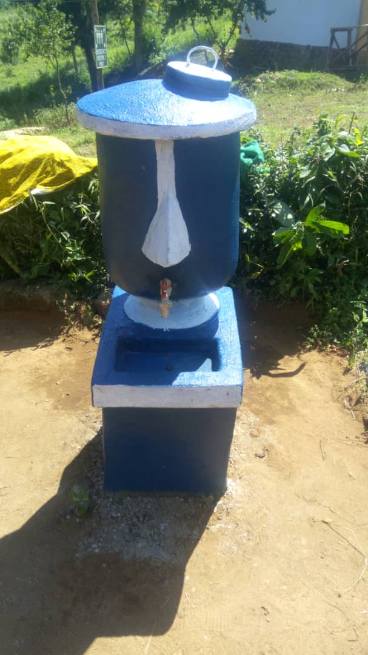
Note:
We have labour charges 78,000/= instead of 100,000/= for two tanks because we paid Issa Kussaga 4 days @ 12,000 /= and his assistant 4 days @ 7,500/= to construct both two tanks, but after that we used to pay only masons 50,000/= per baby calabash without assistance.
- Two Baby Calabash tanks in Lukozi area:
We have also constructed two baby calabash in Lukozi area in front of Office (Ward executive officer Office) and another in Lukozi centre in market area.
- Cost of constructions for the two baby calabash tanks in Lukozi area is as follows:-

S/No | ITEM | COSTS
1. | Labour | 100,000.00
2. | Materials | 117,000.00
3. | Transport | 10,000.00
 | TOTAL | 227,000.00

- Four baby calabash tanks in Usambara schools.
We have constructed four baby calabash in Usambara Schools one was constructed 100% and three others constructed 70% by owner and 30% by project (Chamavita).
Costs of constructing one tank (100%) from owner (Usambara Schools)
S/No | ITEMS | COST
1. | Labour | 50,000.00
2. | Material | 55,000.00
3. | Transport | -
 | TOTAL | 105,000.00

Cost of constructing three baby calabash tanks in Usambara Schools.
S/No | ITEMS | COST
1. | Labour | 150,000.00
2. | Material | 175,500.00
3, | Transport | 25,000.00
 | TOTAL | 350,500.00

One baby calabash tank was constructed in Nkundei village office.
Cost of constructing this tank is as follows:
S/No | ITEMS | COST
1. | Labour | 50,000.00
2. | Material | 55,000.00
3. | Transport | 30,000.00
 | TOTAL | 135,000.00

One baby calabash in RUWASA office Lushoto (Rural Water Services Agency)
Cost of construction is as a follows:
S/No | ITEMS | COST
1. | Labour | 50,000.00
2. | Material | 55,000.00
3, | Transport | 20,000.00
 | TOTAL | 125,000.00

SUMMARY OF INCOME AND EXPENDITURE
- INCOME
No | SOURCE | AMOUNT IN EURO | RATE | AMOUNT IN TSHS
1. | SPOT T | 460 | 2640 | 1,214,400.00
2. | Usambara Schools  70% of 3 tanks |  |  | 240,000,00
 | TOTAL |  |  | 1,454,400.00

- EXPENDITURE:
No. | BABY CALABASH | COST (TSHS)
1. | Lukozi(two tanks) | 227,000.00
2. | Kinko and Chamavita Office (two) | 205,000.00
3. | Usambara Tank (3 tanks) | 305,500.00
4. | Usambara (1 Tank) | 105,000.00
5. | Nkundei Office (1 Tank) | 135,000.00
6. | RUWASA Office (1 Tank) | 125,000.00
 | TOTAL COST | 1,102,500.00

In total 10 Baby Calabash are constructed so that is below the estimated cost price of 46 Euros.

Balance remaining: 351,900.00.

Number of Baby Calabash which can be constructed from the remaining:

- In case the prices in Lushoto remain the same one can construct still 351,900 divided by 110,250 (the average costs of 10 Baby Calabash) is 3.2 Baby Calabash which can still be constructed.

- In Euro’s for an exchange rate of 1=2,830 Tshs it means a value of €124 which is about the value for the construction costs of 2.7 Baby Calabash Tanks.

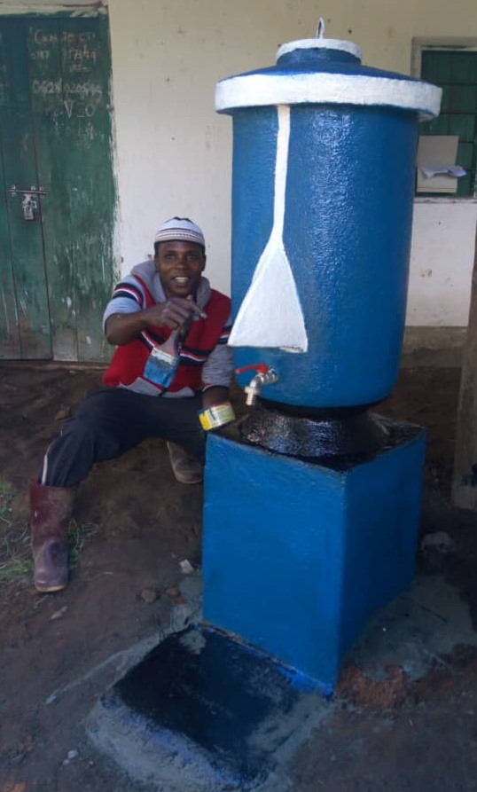
Issa Kussaga constructed this Calabash tank. This one is inclusive a stand on which it is positioned. It can also be positioned on a wall or on concrete blocks.

